# Requirements

**THE MIND MAP**

https://miro.com/app/board/o9J_kjKpWic=/

## Introduction

The purpose of the requirements phase is to allow for developers to work out what the application should be able to do. It is important to understand what the users would like the application to do rather than the developer deciding what is required.

You can write a bit about your project area. Each paragraph has a blank line between it and the previous paragraph

What is the name of your game?

What game genre does it fall into?

Is it multiplayer or single player?

Briefly describe the game mechanics.

Briefly describe the style, design, and graphics.

Our application will be a game made with the Unity engine. It will be a 3D, open-world exploration and survival game where you play as a variety of animals.

## Requirements gathering

### Similar applications

Three similar applications I researched while developing this project were the games Goat Simulator, Wildcraft, and The Isle. These are all games where the player takes control of an animal and faces challenges and obstacles in a large, 3D environment.

Look at and document three similar applications. Be sure to include the following for each:

* Screen shots

#### Goat Simulator

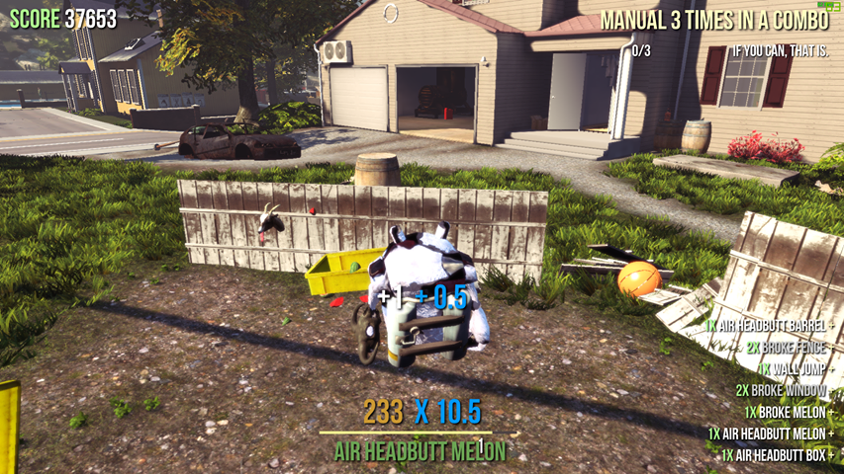

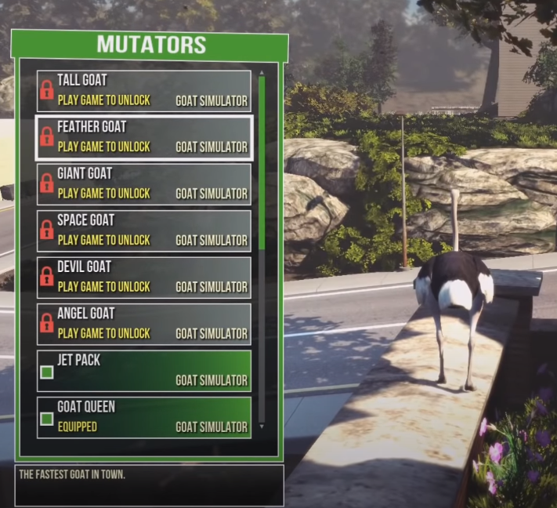

#### Wildcraft

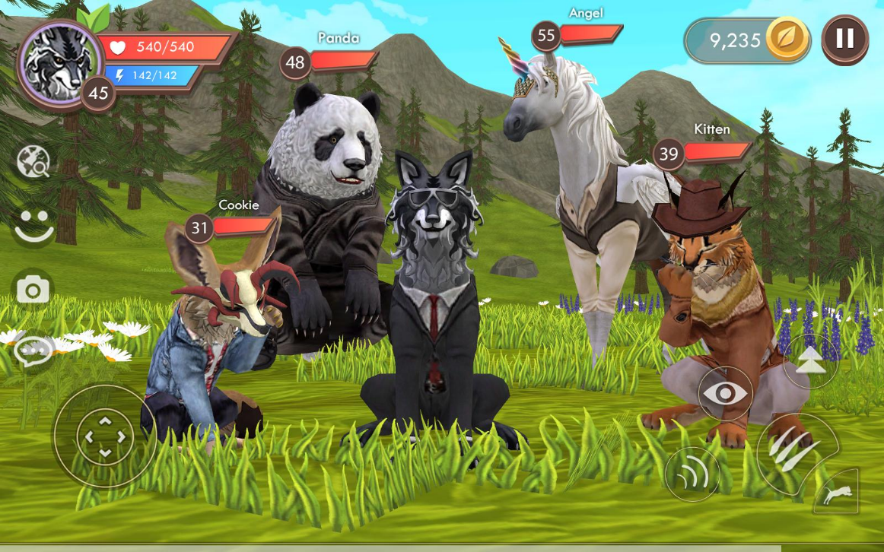

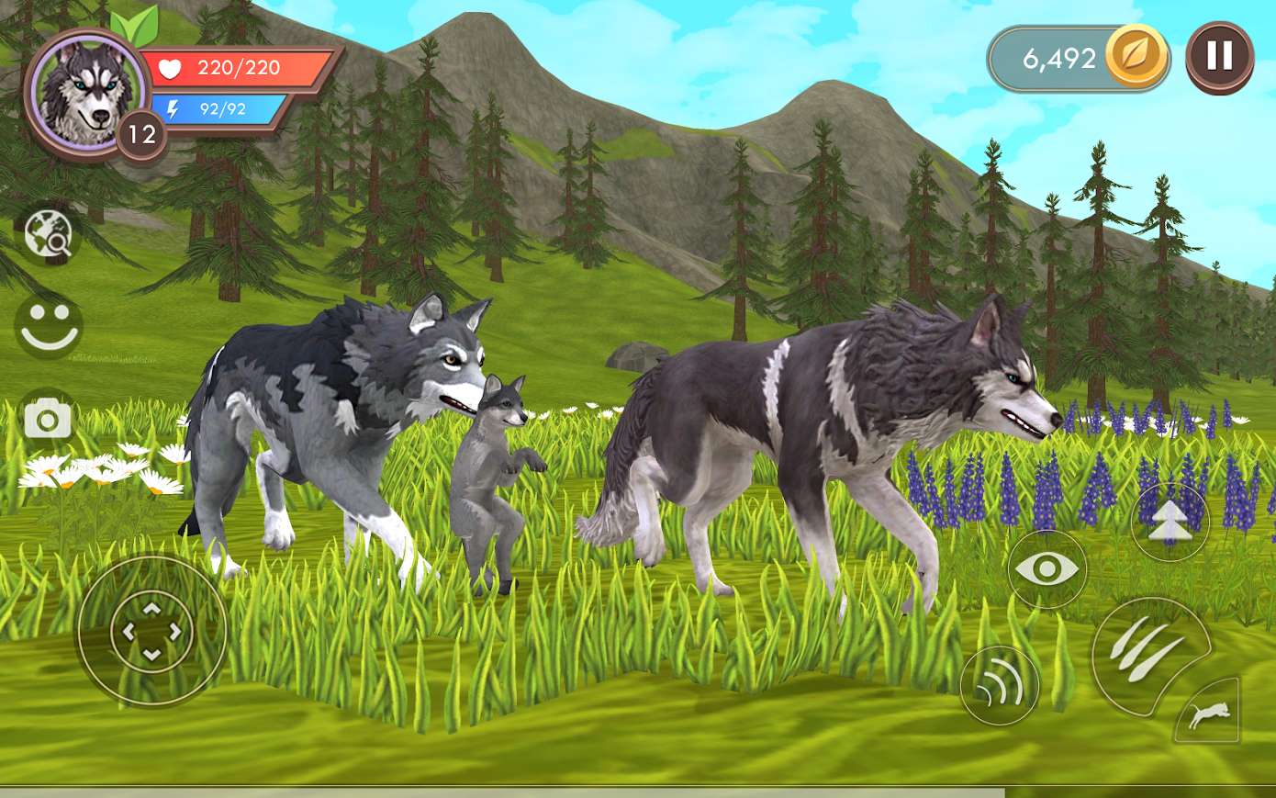

#### The Isle

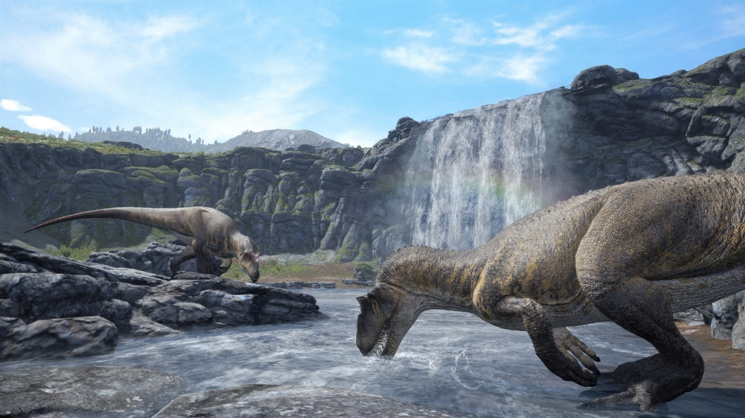

* Descriptions
* Advantages
* Disadvantages

### Personas

These are fictional characters to help the developer understand the users’ needs. They also help identify who the relevant users are.

This website was used to create personas: <https://www.hubspot.com/make-my-persona>

Persona 1

Persona 2

Persona 3

### Interviews ✓ 9/10/2020

Conduct interviews with 3 or 4 users to find out what the important features for them for the app are. There may be various issues that arise in multiple interviews. These can be grouped together into a number of themes.

We asked 2 other classmates who are developing a fps parkour game.

Questions 1:

Answer:

### Survey ✓ 12/10/2020

You can create a questionnaire and use the results of the questionnaire as a basis for finding out requirements.

<https://forms.gle/NBuTSXrZnVfgFXjN8>

## Requirements modelling

### Functional requirements

Create a numbered list of what the application should be able to do. Start with the most important feature.

TOP 10 Features + brief description:

1. Sandbox:
2. Open World:
3. Points System:
4. Choose your animals:
5. Visual descriptions:
6. Stats:
7. Game logs:
8. 3rd person:
9. Collectibles:
10. Achievements:

### Non-functional requirements

These are requirements which if not met do not stop the application from working, but which mean that the application is not working as well as it should. They are usually based on issues such as:

* Usability

Talk about bugs, make references to the other games

* Performance

Talk about performance requirements, is it resource intensive, can it run on mobile, tablets or only on console and a gaming pc?

* Security

Will it require user credentials, is there a login system, is there auto-save and where will it be saved?

### Use Case Diagrams

Consists of actors and use cases. You should document each individual use case.

??????????????

## Feasibility

This section describes which technologies are planned to be used in the development of the application. It then explains if there are any issues in terms of the technical feasibility of the project, for example, if there are two different types of software which may have compatibility issues.

TOP 5 TECHNOLOGIES:

1. Unity for game development
2. Visual studio code for coding
3. Miro for brainstorming
4. Trello for project management
5. Photoshop for designing
6. Possibly blender

## Conclusion

Write a couple of paragraphs summing up the chapter. Explain what area your project is about. Describe what the chapter has discussed.

??????????????

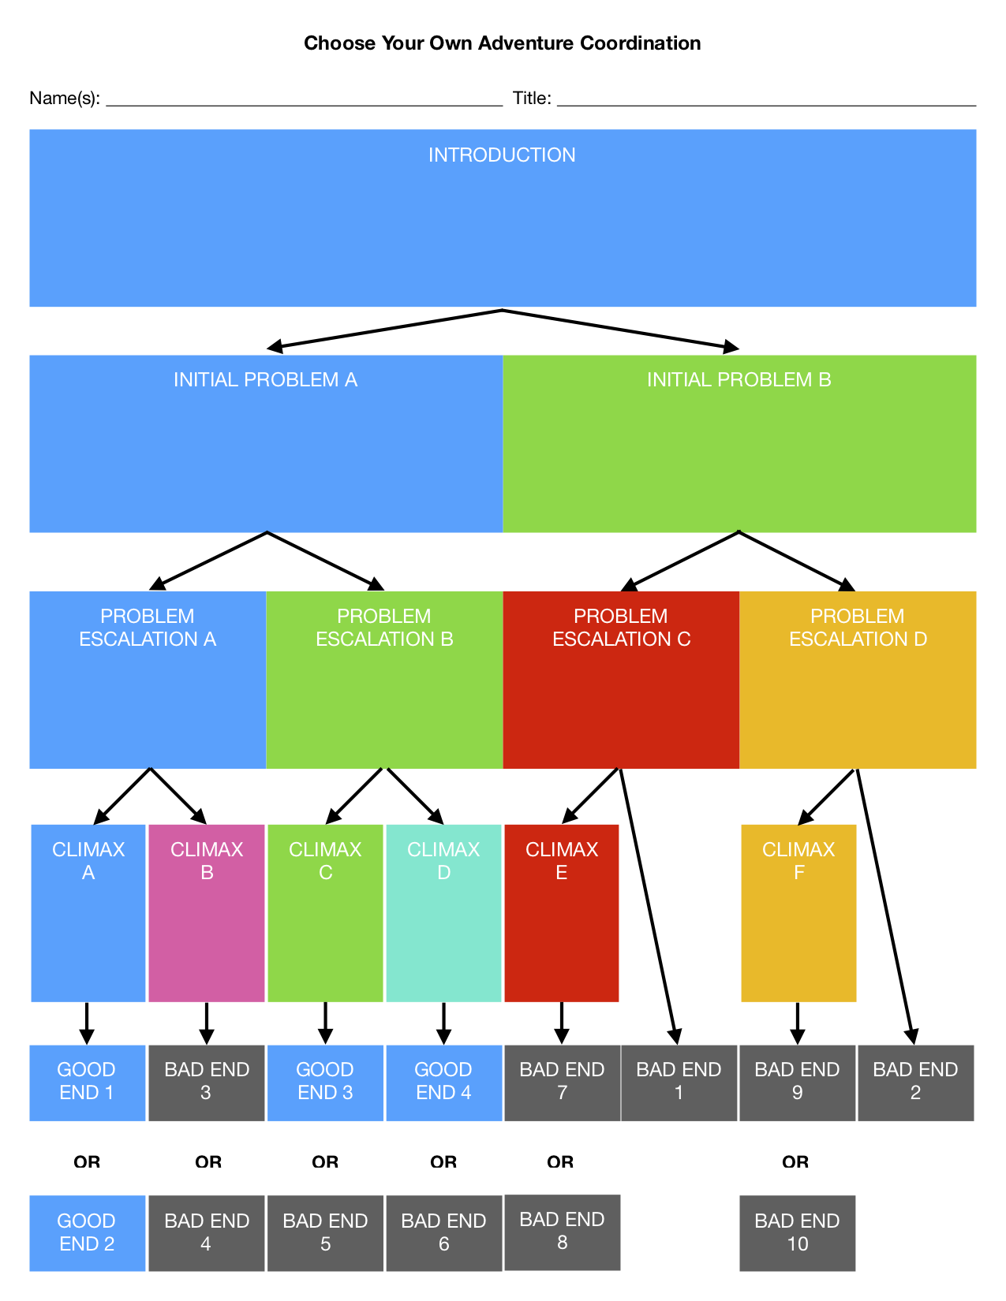

Figure 1 https://braveintheattempt.com/2017/10/30/google-forms-game-based-learning/